MYT1 Series of electro-hydraulic pusher

Instruction Manual

JIAOZUO HONGFA BRAKE CO.,LTD

Add: Jiaozuo City Hongqiao Industrial Zone
Tel:0391-7541838
Fax:0391-7542897
http:www.jz-hfzd.com
E-mail:jz-hfzd-999@163.com
Zip code :454981

MYT1 series of electro-hydraulic pusher（hereinafter referred to as the pusher），apply to AC50Hz、550V network，Mainly as drum brakes loose brake use。You can also make a variety of different sports through various forms of leverage device, which MYT1-320Z/15 mine winch design.
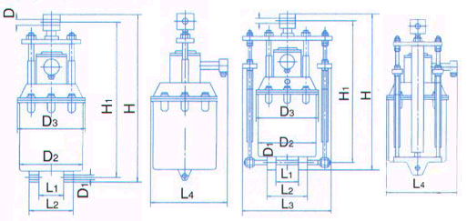
一、Conditions of use.
1、Altitude less than 1000m.
2、Circumferential medium temperature：+40℃ to —25℃；
3、Air relative humidity no higher than 85%；
4、No rattling and strong turbulence;
5、Surrounding medium non-explosive danger, and not place conductive dust
and corrode metal and damage the insulating gas；
6、Have anti-rain and snow equipment and no place is full of water vapor。
二、Model implication

MYT 1 — 320 Z / 15
Electro-hydraulic pusher Rated travel：（×10mm）
Design number Code：no load spring
三、Structure and working principle Rated thrust：（×10N）

Pusher mainly consists of three parts: Motor, hydraulic pump and hydraulic cylinder. Motor shaft is hollow, By coupling with square shaft coupling, Square shaft end mounted centrifugal impeller. When the putter operation, The square shaft to slide up and down in the hollow motor shaft, to transmit torque.
When the motor is energized, driving the rotation of the impeller, the fluid is forcibly pressed into the bottom of the piston, forcing the piston to rise, driven pusher rise. Power outage，stop the rotation of the impeller, the piston in the recovery in situ under the action of its own gravity or the spring force.

四、Technical data (Table 2) and dimensions (Table 3)

五、Installation and maintenance
1、Promote the installation Dimensions shown in Figure and Table 3
2、Check pusher nameplate on technical data are consistent with the required technical data.
3、Pushers should be cleared before the pusher appearance grease, oil meet the following table 1 and then cover the filling hole injection. The power is turned on, check the impeller rotation is flexible, the push rod and the piston catching.
4、In the brake is installed, will pusher the mounting hole of the lower portion is connected to the brake base, the rod and the brake angle lever connected.
5、The lead line of the motor is connected to the external power supply。
6、Pushers should pay attention to the use of:
（1）Regular refueling;
（2）Note that the oil clean, if necessary, replace the oil;
（3）Impeller rotation is flexible;

Table 1
The ambient temperature | Recommend use of oil
+40℃~+20℃ | 20﹟Machine oil
+20℃~0℃ | 10﹟Transformer oil
0℃~—15℃ | 25﹟Transformer oil
—15℃~—25℃ | 10﹟Aviation fuel

Table 2

Table 3

